Instructions for Human Subjects CITI Training

- Go to the ORI IRB website at http://integrity.uncg.edu/institutional-review-board/

- See the Training heading at the top of the page.

- Click on the link for CITI training website. CITI is the preferred training for human subject’s research.

- The CITI website will open in a new window (please be sure that popup blockers are disabled, otherwise the window may not open).

- If you do not have a CITI account, please click the “register here” link to create your account. If you are already registered, login with your credentials and proceed with step # 8 below.

- If you have a CITI account but are not affiliated with UNCG, you will need to affiliate. Once logged in to CITI, choose “Click here to affiliate with another Institution”. Under the dropdown “Participating Institutions”, select “University of North Carolina at Greensboro”, then select “Next”.

  - If you would like to receive credit for modules previously taken, there are several requirements that must be met.

- To transfer course credit between institutions, you will need to be affiliated with both institutions (your previous institution and your new institution). Follow the "Click here to affiliate with another institution" link on your Main Menu to add an affiliation.
- When you are affiliated with both institutions, enroll in the courses that need to be transferred under both institutions, via the "Add a Course or Update Learner Groups" link under the appropriate institution if necessary. You will need to enroll in the same stage of the course (Basic / Refresher) for a proper transfer to occur.
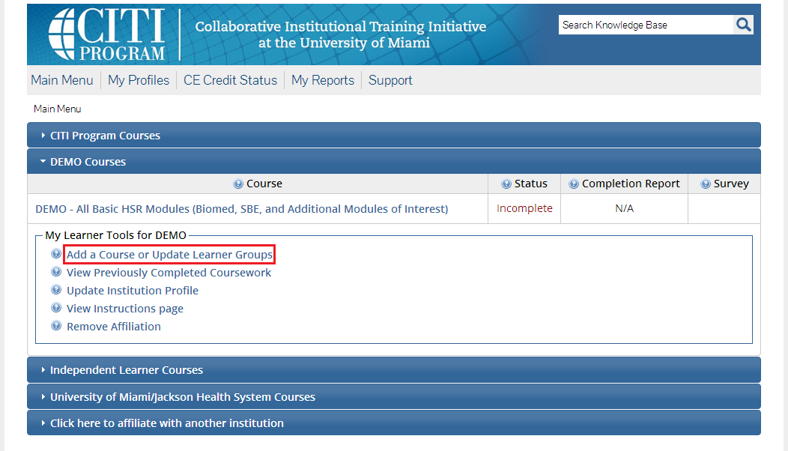

- Once you are enrolled in the courses, any modules that are shared between the courses between institutions will have their credit transferred automatically. The transfer is based on each module's unique ID number. If the courses do not match exactly, not all credit will transfer and you may need complete the difference in modules at your new institution to get full credit for a Completion Report.
- Each institution determines the time frame in which modules are transferable. This time frame can span any time between 1 and 10 years. Some institutions opt out of this option and do not allow modules to transfer.

- If you need to create a new account, you will be asked a series of questions. Select UNCG as the participating institution and enter all required name/address information. Please use your UNCG username as your CITI username in order to assist the ORI office with verification of training.

- Please be sure that you enter your UNCG Employee/Student ID number. If you are NOT affiliated with UNCG, please enter 9 zeros as your ID number. This is how you will be verified by the IRBIS online submission system and if we cannot verify you by your UNCG ID, it will delay processing of your submission. If you do not know your employee/student ID number, please contact HR at 334-5009 if you are an employee and the Admissions Office at 334-5243 if you are a student.

- You will then get to the member information page. Under “University of North Carolina at Greensboro Courses”, please click “Add a Course”

- Question 1 – Getting Started – Select “Human Research”, click “Next”

- Question 2 select: Researcher Module if you are faculty or Student Researcher Module if you are a student. (these are the ONLY accepted modules)

  - Note: If you intend to do international research you will need to come back and add the International Researcher module later OR select it as an elective module once you have begun your course.

- Once you have made your selection in question 2, click the next question button.

- Question 3 – if you are faculty/staff or a student select “not applicable” as these modules are only for the institutional official

- You should receive a message that states “Your request has been successfully submitted and you will see your selected module under “Course”

  - Click on your selected modules under “Course” to begin your modules. Once you begin your work, you are free to complete the work at your own pace. You have the ability to log out and return again without losing your completed work.

- Please remember that if you are doing international research you will need to select that module separately via another login session.

