Instructions for Completing External Professional Activities for Pay (EPAP) via AIR
As required by Regulations on External Professional Activities for Pay by Faculty and Non-Faculty EPA Employees, (UNC policy 300.2.2.1[R]), The University of North Carolina at Greensboro seeks to appoint and to retain, as employees, individuals of exceptional competence in their respective fields of professional endeavor. Because of their specialized knowledge and experience, these individuals have opportunities to apply their professional expertise to activities outside of their University employment, including secondary employment consisting of paid consultation or other service to various public and private entities. These practical compensated applications of their professional qualifications enhance capabilities in teaching, research, and administration. Thus, participation of employees in external professional activities for pay, typically in the form of consulting, is an important characteristic of academic employment that often leads to significant societal benefits, including economic development through technology transfer. However, External Professional Activities for Pay are to be undertaken only if they do not:
- Create a Conflict of Commitment by interfering with the obligation of the individual to carry out all University employment responsibilities in a timely and effective manner;
- Create a Conflict of Interest because of the individual's status as a Covered Employee of the University;
- Involve any inappropriate use or exploitation of University resources;
- Make any use of the name or marks of the University of North Carolina at Greensboro for any purpose other than professional identification; or
- Claim, explicitly or implicitly, any University or institutional responsibility for the conduct or outcome of the External Professional Activities for Pay.

- Start by going to the AIR homepage: https://uncg.myresearchonline.org/air/
Note: If the link does not work for you, please try using another browser. If that doesn’t work, then contact David Starnes at dastarne@uncg.edu or 336-256-2601.
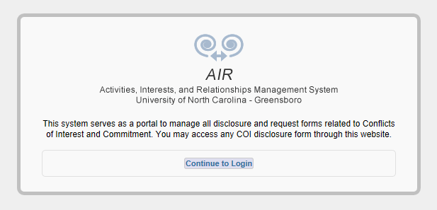

- Click on “Continue to Login”. You will land on the UNCG Authentication page, where you can login using your UNCG credentials. This will take you to your AIR homepage.
- Click on the “Notice of Intent to Engage in External Professional Activities for Pay” link. This will take you to the Contact Information and General Questions page for the EPAP Disclosure process.

- Enter your last name and click “Search”.

- A list of individuals with your last name will appear. Click on your name. If your name does not appear, please contact David Starnes at dastarne@uncg.edu .
- The contact information section should now include all of your contact information. This section pulls information from a separate database, so contact information cannot be manually updated or edited within AIR. If corrections or updates are needed, please contact David Starnes at dastarne@uncg.edu.

- Be sure to read and complete the General questions. The drop down menu will allow you to search by key words for the contracting organization or sponsor, or to add if the entity is not listed. Answer the remaining questions as completely as possible; click on Save and Continue.
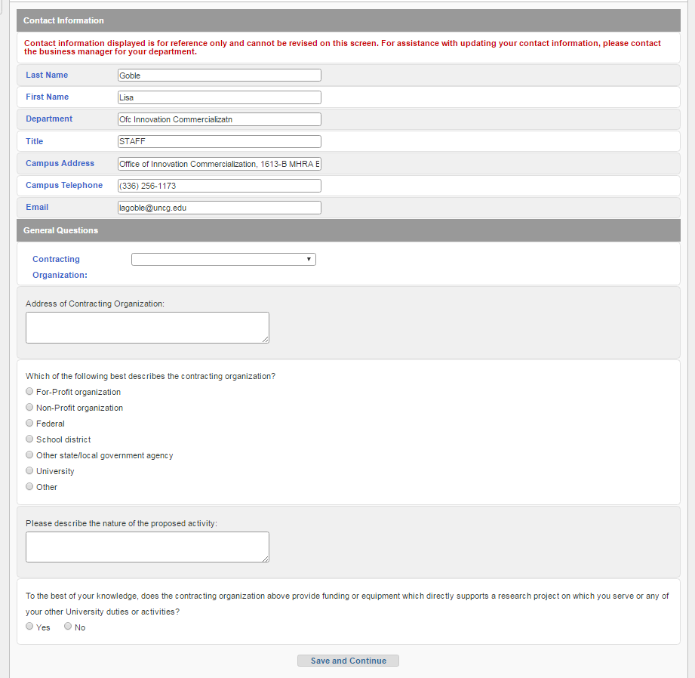

If you answered yes to the last question, a COI warning will pop up and you will be asked to submit responses to additional questions, click OK and provide additional information on the funding provided by the contracting organization and your role in that project, then click on Save and Continue.

- The subsequent screen asks for information directly related to the proposed activity. Enter your role, the expected frequency of activity, be sure the time frame is within the current fiscal year (July 1 – June 30th), and enter the estimated time commitment and list of activities you may miss due to this external activity.

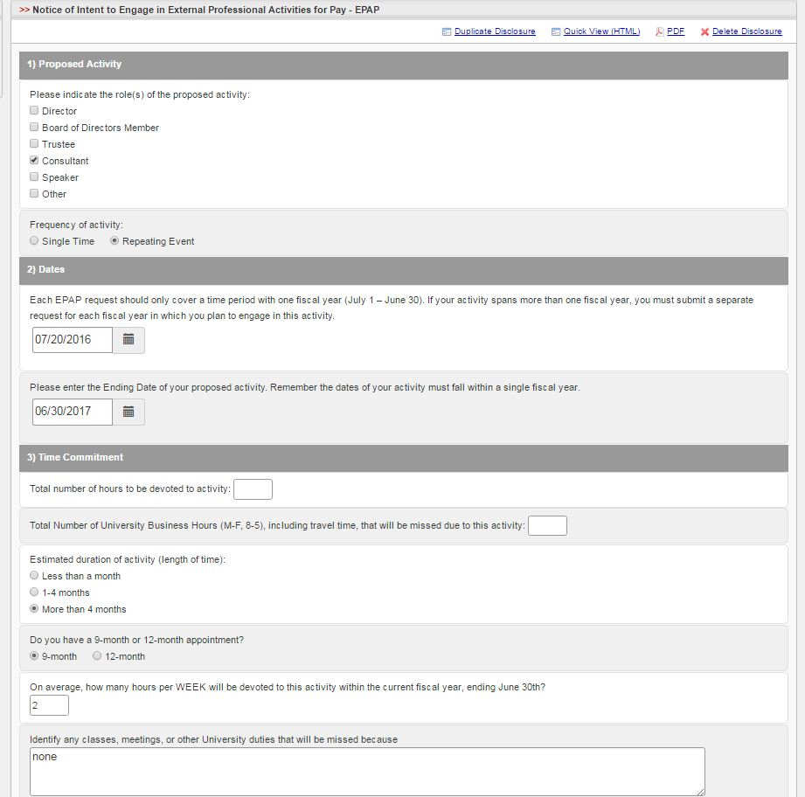

- For the next series of questions 4 through 9, if you click yes, a pop-up screen will appear where you will be prompted to provide detailed information. Answer the questions as thoroughly as possible, and save.

Finally, provide any additional information that might be relevant to the activity, certify the information is complete and correct, and click Save and Continue

- Once you’ve completed that section, your EPAP disclosure will be routed to your departmental reviewer(s). The subsequent screen will provide information on the department reviews, and the status history.

