Citi Training – Export Control for PIs and others engaged in research with foreign nationals
https://www.citiprogram.org/
Introduction to Export Compliance (ID: 16800)
Export Compliance When Using Technology in Research (ID: 16804)
Export Compliance for Researchers: Part I (ID: 16801)

- The CITI website will open in a new window (please be sure that popup blockers are disabled, otherwise the window may not open).

- If you do not have a CITI account, please click the “register” link at the top to create your account. If you are already registered, login with your credentials and proceed with step # 4 below.

- If you have a CITI account but are not affiliated with UNCG, you will need to affiliate. Once logged in to CITI, choose “Click here to affiliate with another Institution”. Under the dropdown “Participating Institutions”, select “University of North Carolina at Greensboro”, then select “Next”.

- If you need to create a new account, you will be asked a series of questions. Select UNCG as the participating institution and enter all required name/address information. Please use your UNCG username as your CITI username in order to assist the ORI office with verification of training. Please be sure that you enter your UNCG Employee/Student ID number.

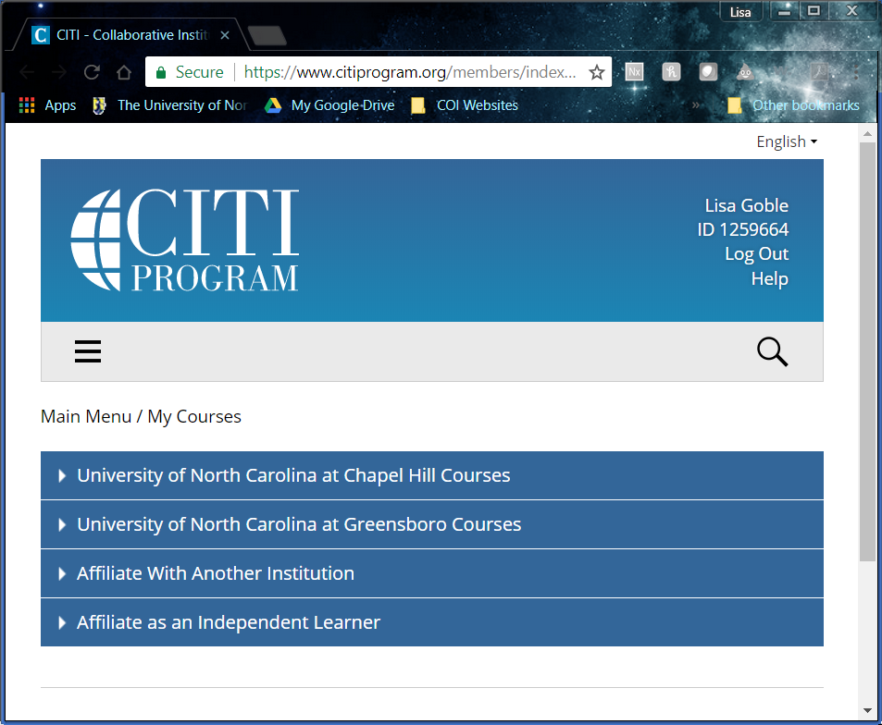
- You will then get to the member information page. Under “my Learner Tools for University of North Carolina at Greensboro, please select “Add a Course”
- Then select Export Compliance

Once you’ve added that course, then you’ll be able to see the modules embedded in the course:
Introduction is the top course, then the other two can be selected from the optional modules.

