- You must have a CITI Program account to access the course. If you, as a learner, do not have a CITI Program account please follow these instructions to register: https://support.citiprogram.org/s/article/updated-guide-to-getting-started
- Here is how your learners can access the course:
  - Visit www.citiprogram.org and log into your account.
  - Click on “View Courses” next to your institution’s name from your Main Menu page.
  - Click on “Add a course” below the Learner Tools section.
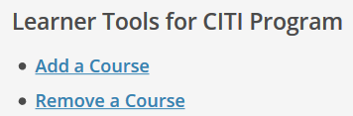
  - Locate the “COVID-19: Back to Campus (Fall 2020)” course (location may vary per your institutions curriculum questions).
- Follow these steps to retrieve your Completion Record after you have completed the course: https://support.citiprogram.org/s/article/how-do-i-access-my-completion-certificate-2019-10-24-17-54-24

