Click the question mark in the lower right-hand corner
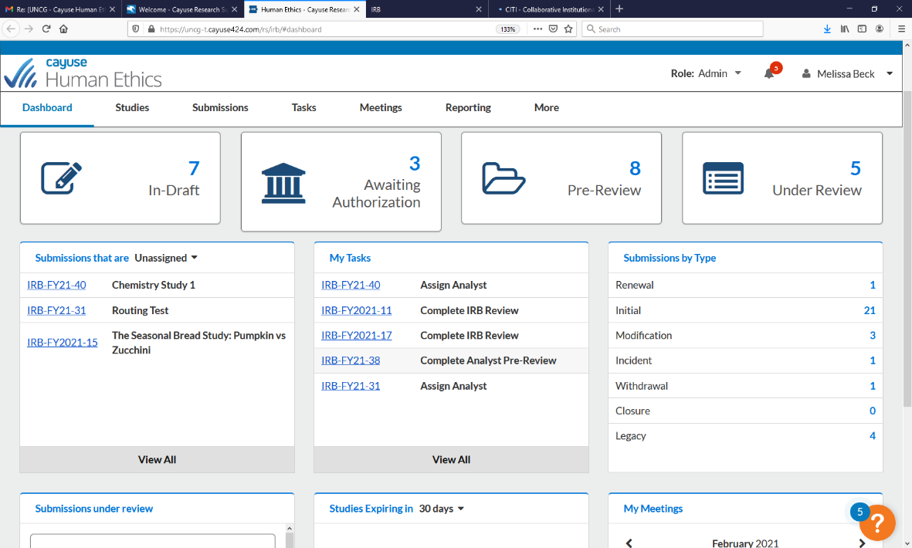
C

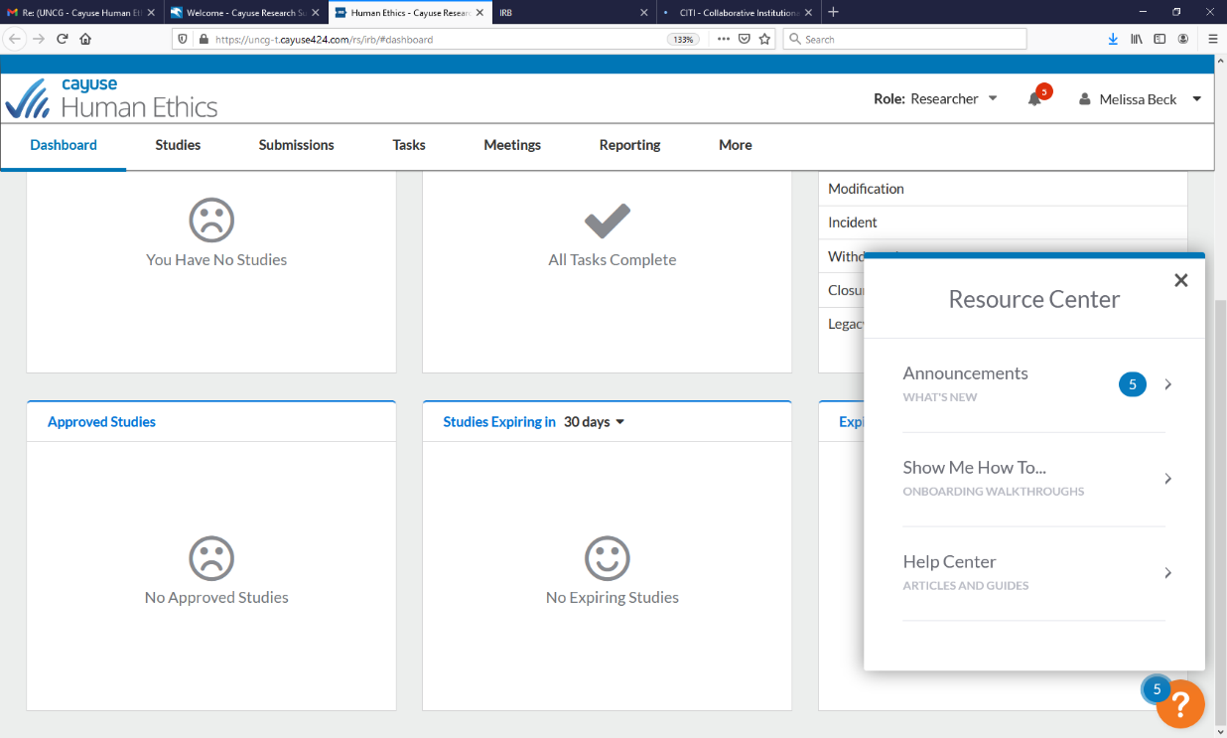
Click “Show Me How To…” for helpful videos or “Help Center” for step-by-step instructions

