- You must have a CITI Program account to access the course. If you, as a learner, do not have a CITI Program account please follow these instructions to register: https://support.citiprogram.org/s/article/updated-guide-to-getting-started
- Here is how your learners can access the course:
  - Visit www.citiprogram.org and log into your account.
You can either sign in with your account information or click “Log in through my institution”, scroll to University of North Carolina at Greensboro, and use your university ID and password.
  - Click on “View Courses” next to your institution’s name from your Main Menu page.
  - Click on “Add a course” below the Learner Tools section.
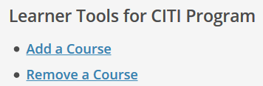
  - Locate the “COVID-19: Back to Campus (Fall 2020)” course (location may vary per your institutions curriculum questions).
- Follow these steps to retrieve your Completion Record after you have completed the course: https://support.citiprogram.org/s/article/how-do-i-access-my-completion-certificate-2019-10-24-17-54-24

