New Study – Step-by-Step Instructions
Login to Cayuse Research Suite, click “Cayuse IRB”
Once on Dashboard – click “New Study”
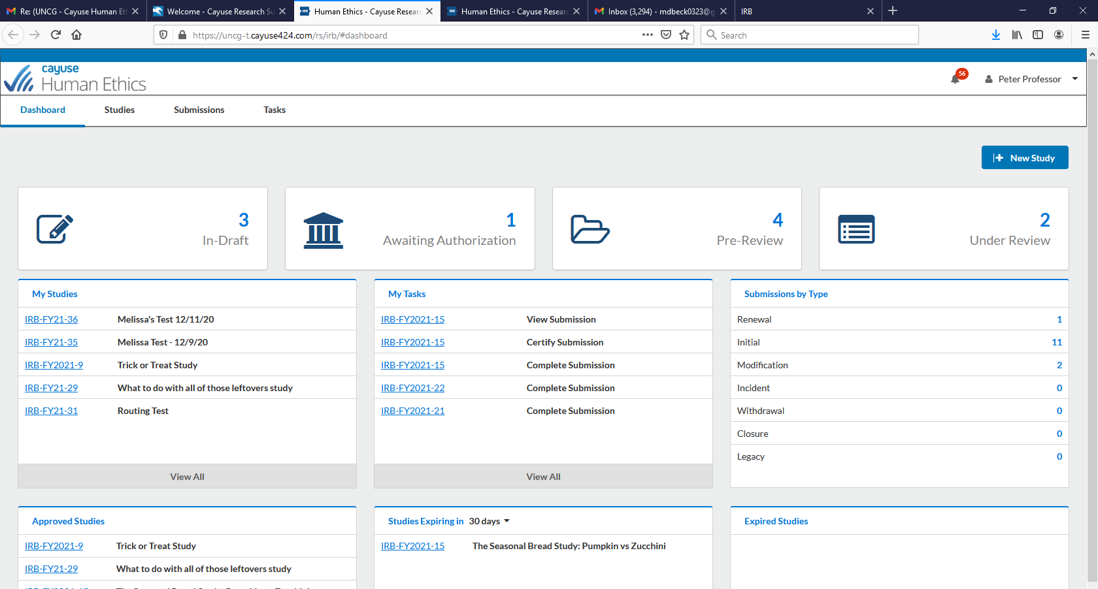

Add Study Title
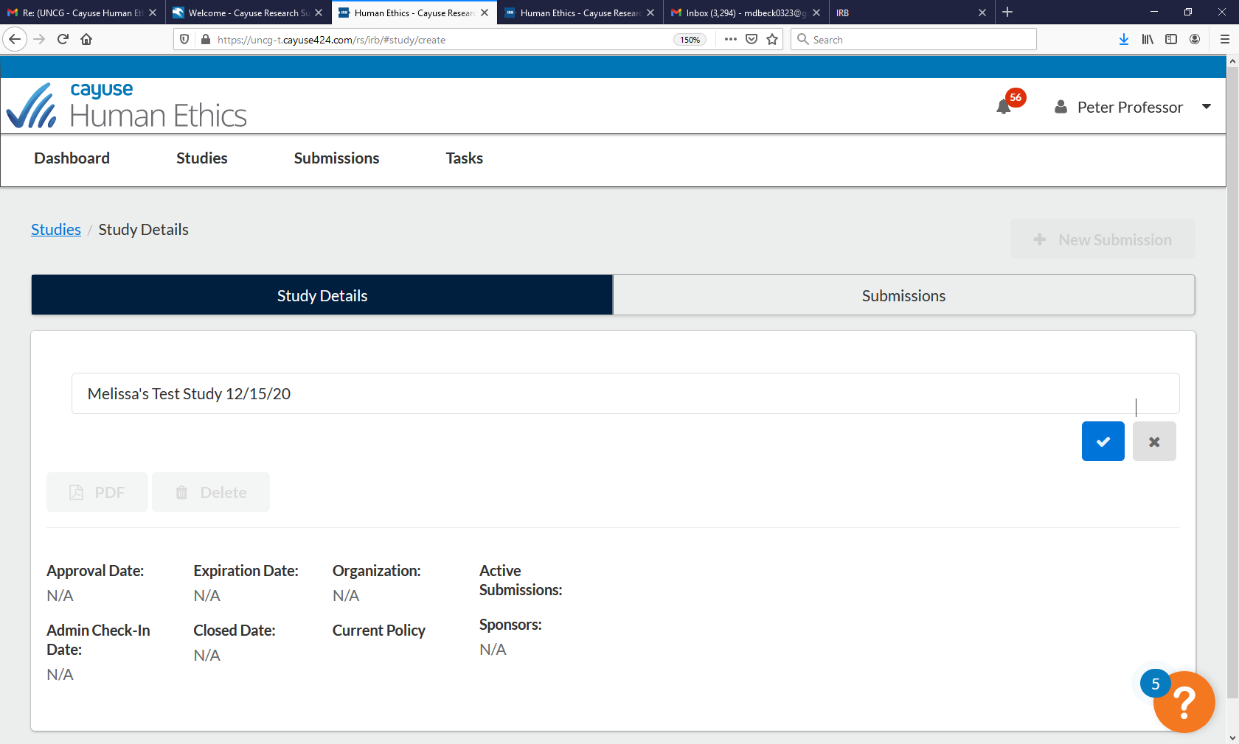
Click blue check mark on right-hand side of page

Click “New Submission”, then “initial”
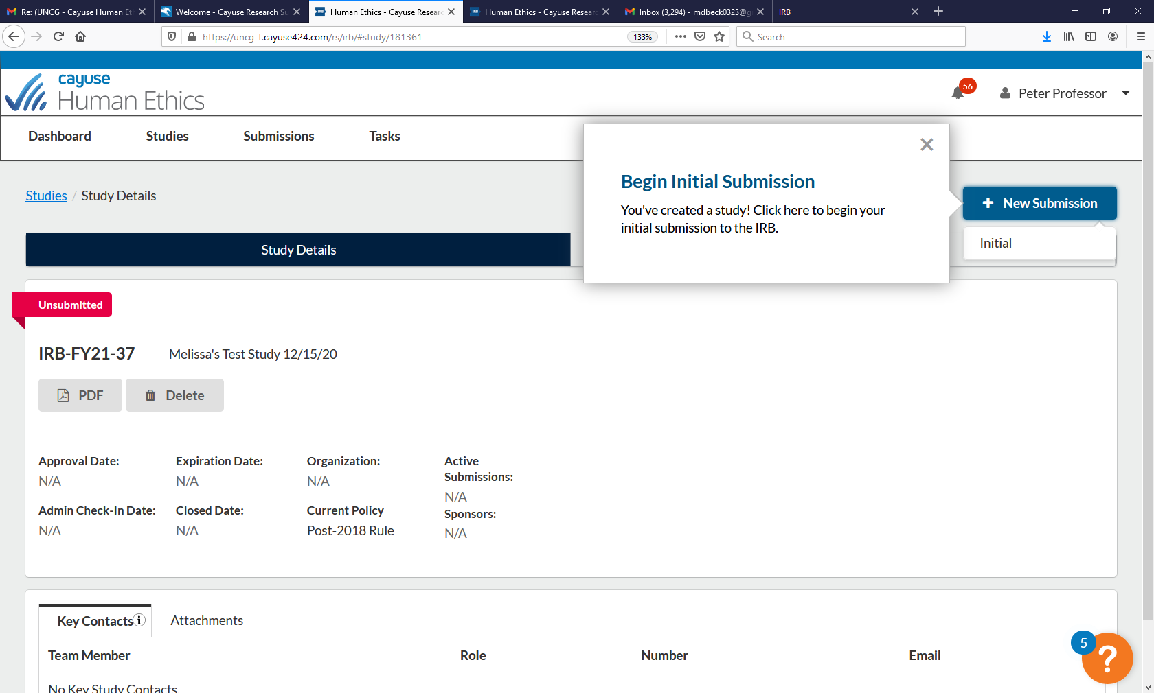
If you are completing the study application on behalf of the PI, click either “assign PI”
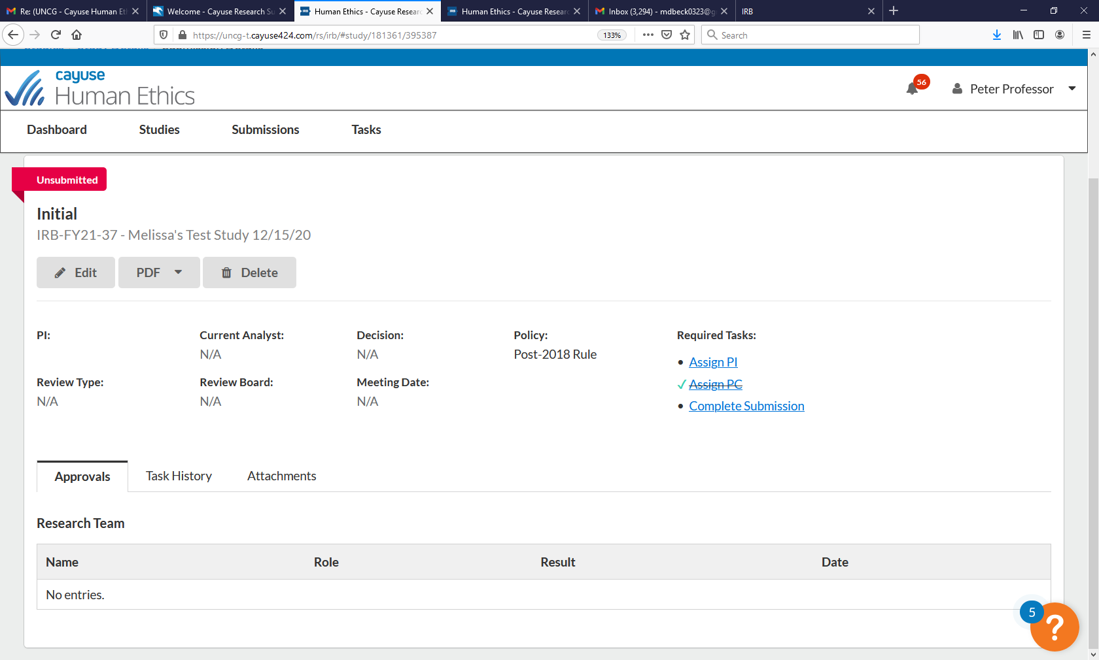

If you are the PI, click either “Complete Submission” OR Edit
Read the information under UNCG IRB – important info!
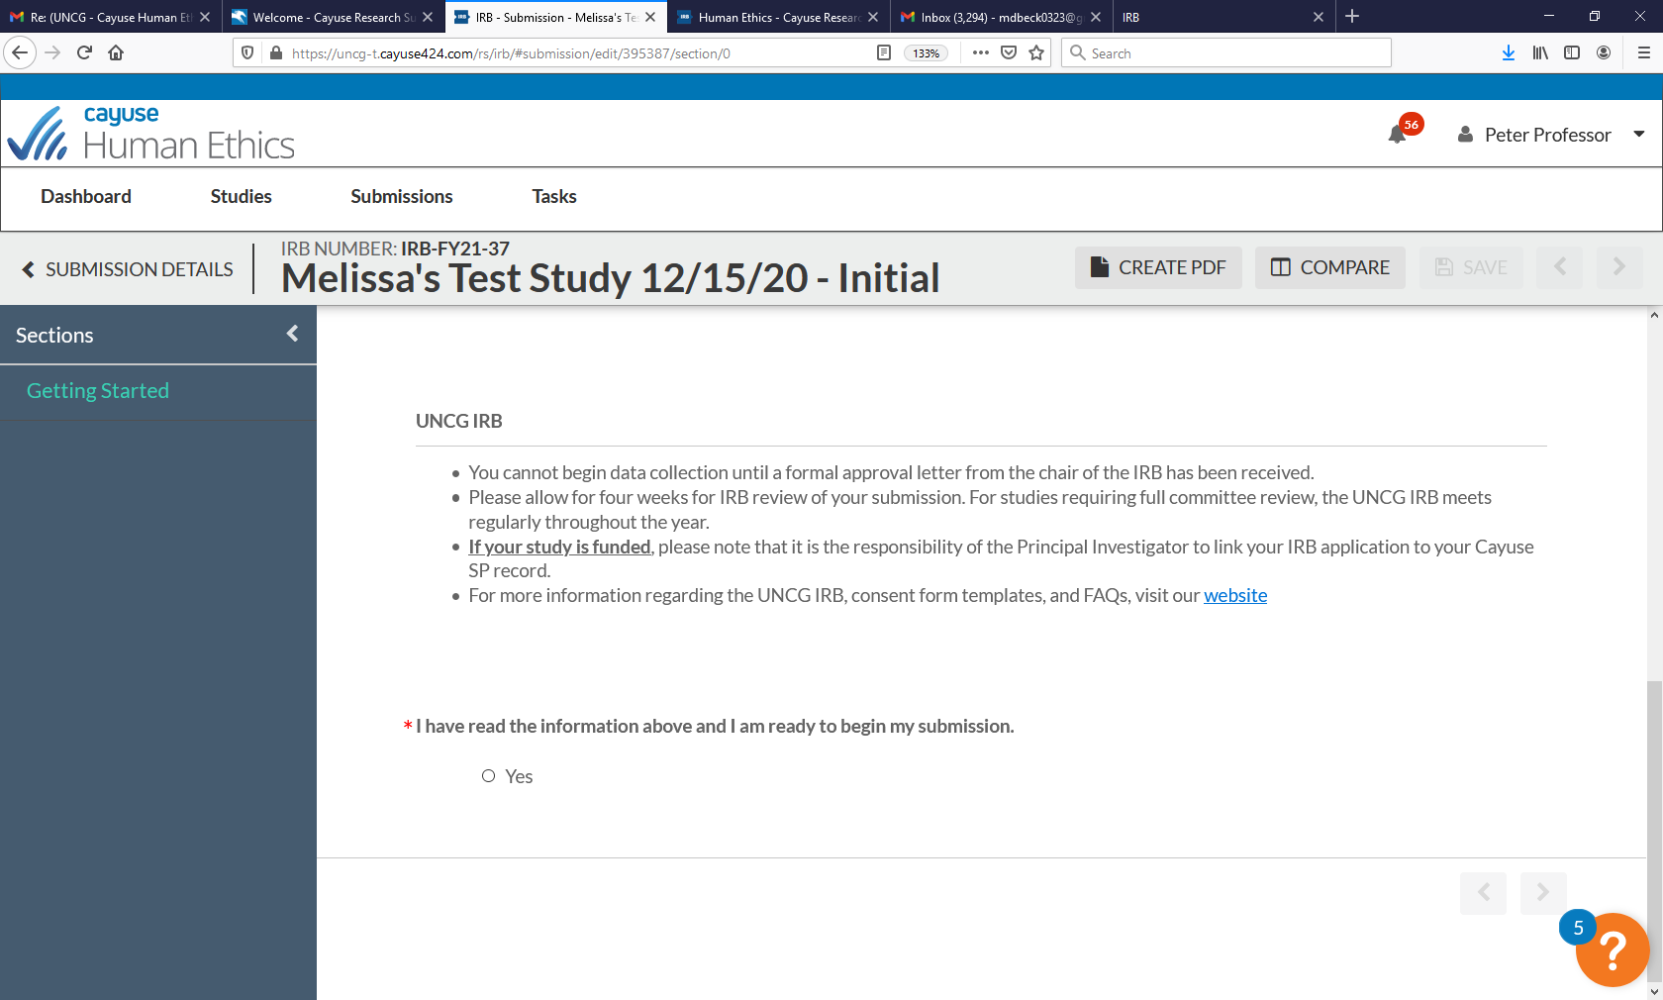

Click the “yes” button to begin the application
Click “Submission Information” on the left-hand side of the page under “Submission Details”
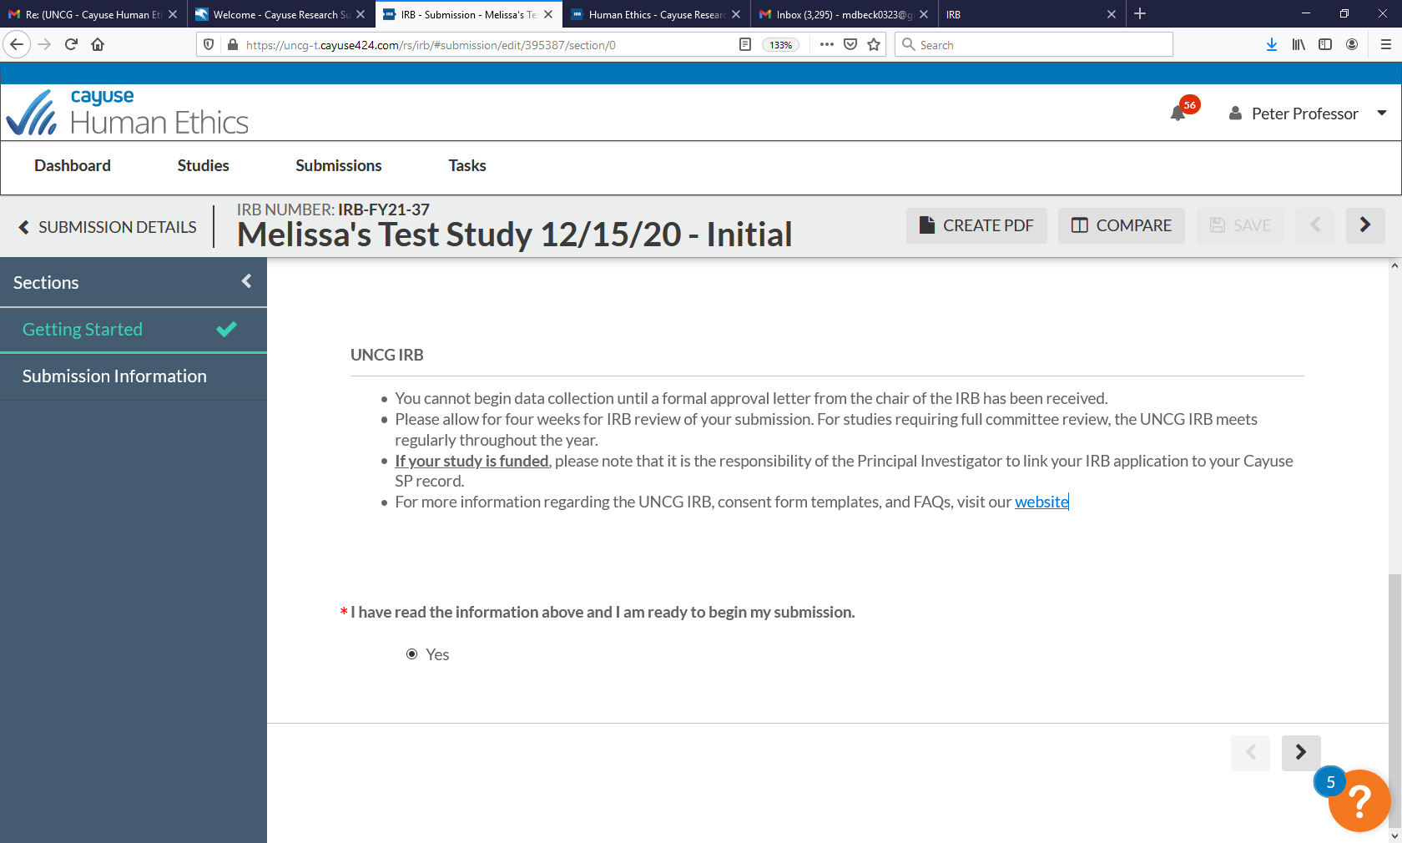
Respond to the screening questions as is applicable to your study – the responses to these questions will determine which sections of study application will appear – NOTE: There is no longer a separate exempt application – the full application will be completed for all review types – exempt, expedited, and full board. The exceptions are the IRB Determination Form (NHSR Form) and the multi-institutional research application where UNCG is not the IRB of record (UNCG is relying on the IRB review of another institution)
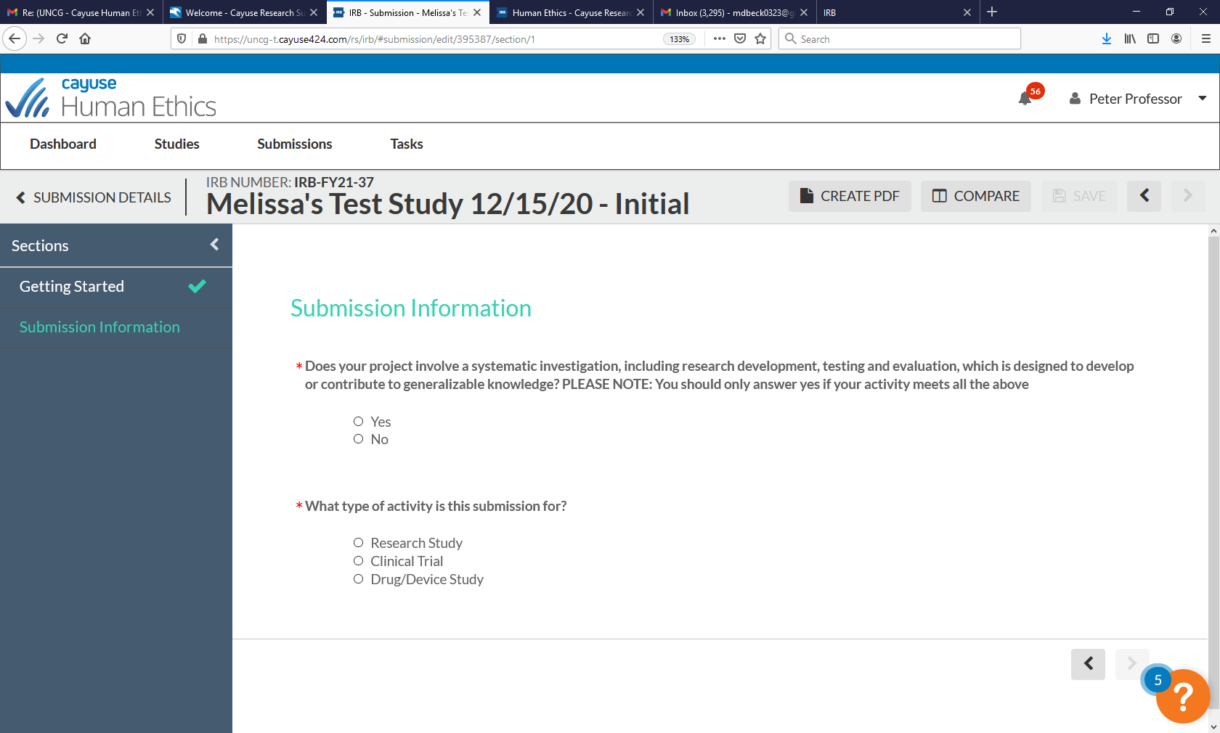
Depending on the response to the first screening question, other questions may appear

You can navigate to the next page by clicking the arrow button on the bottom of the page or by clicking the next section header on the left-hand side of the page
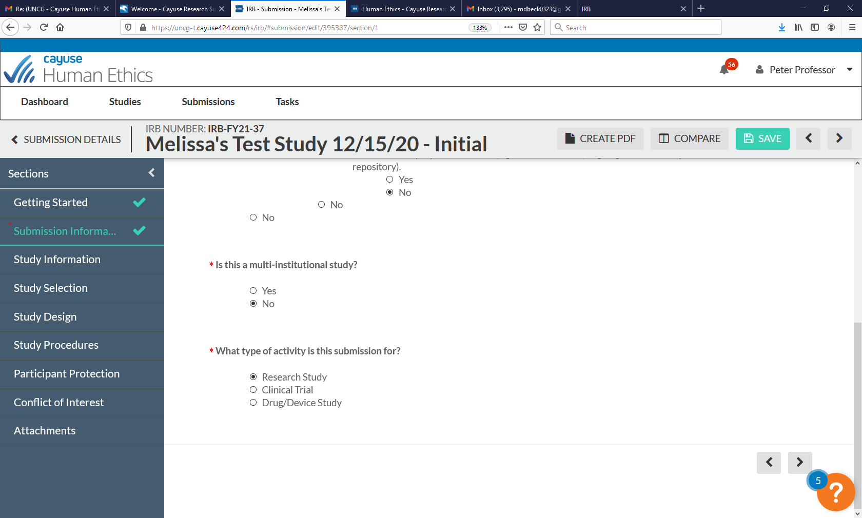
Indicate the status of the “PI” of the study
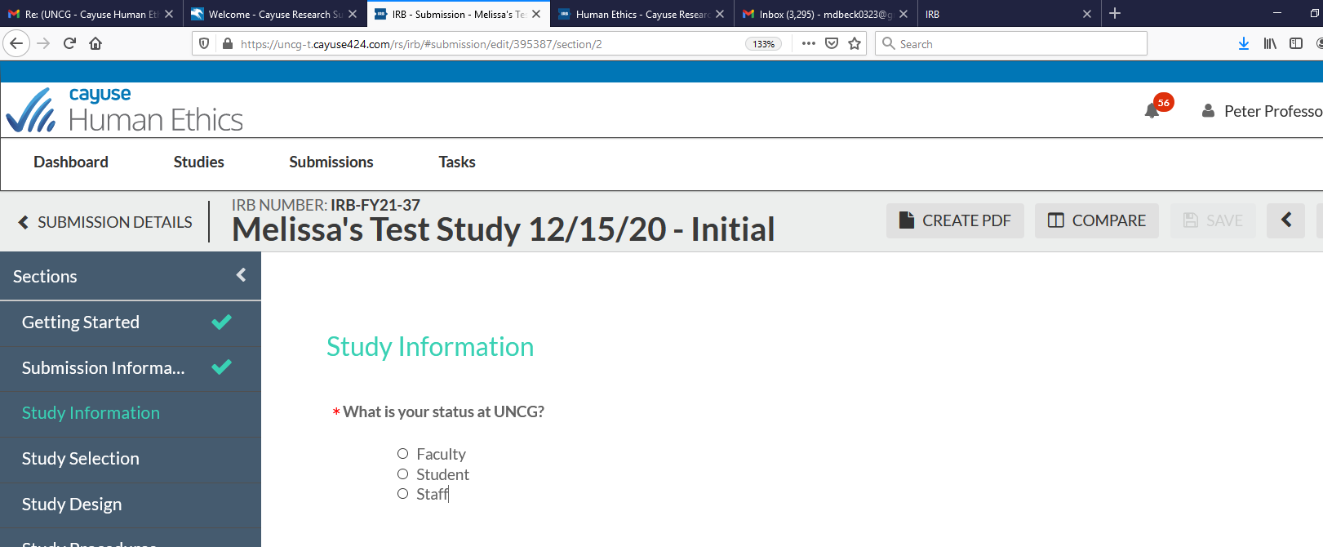

Note: If a student: both undergrad and graduate students are required to input their anticipated graduation date – this is so a reminder can be sent to them to close out the study
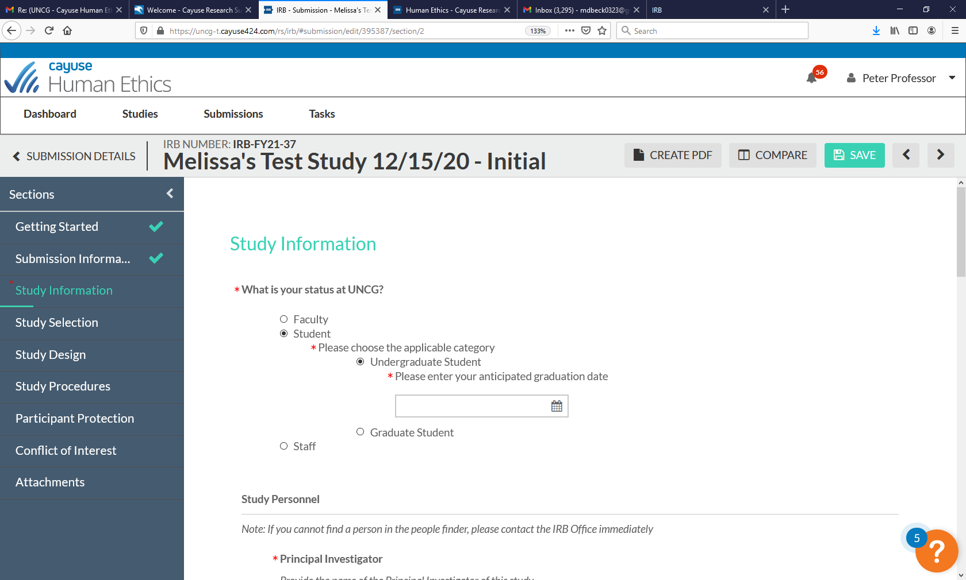
Use the “Find People” button to find UNCG-affiliated personnel
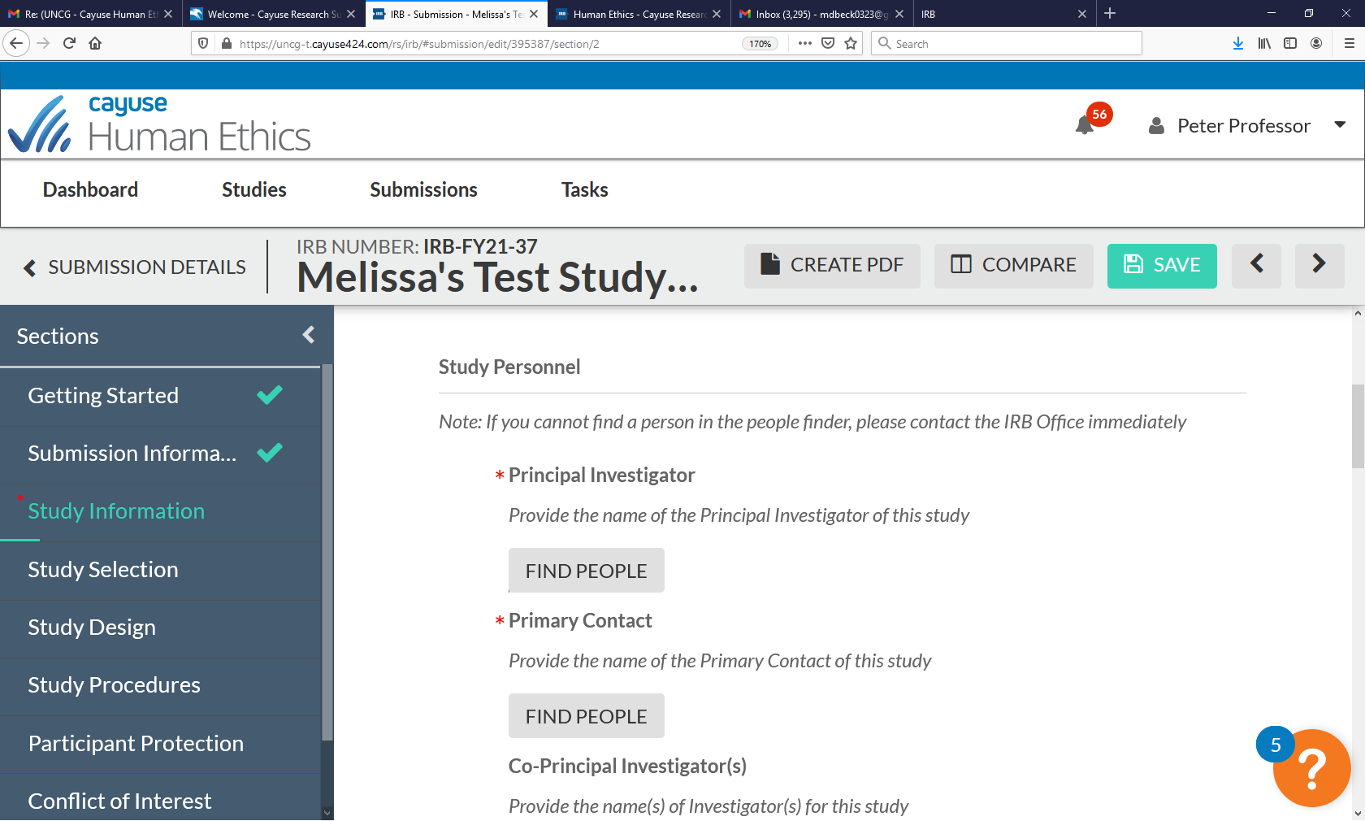
Type the person’s name into the search box, then hit either “enter” or the magnifying glass to the right of the search box
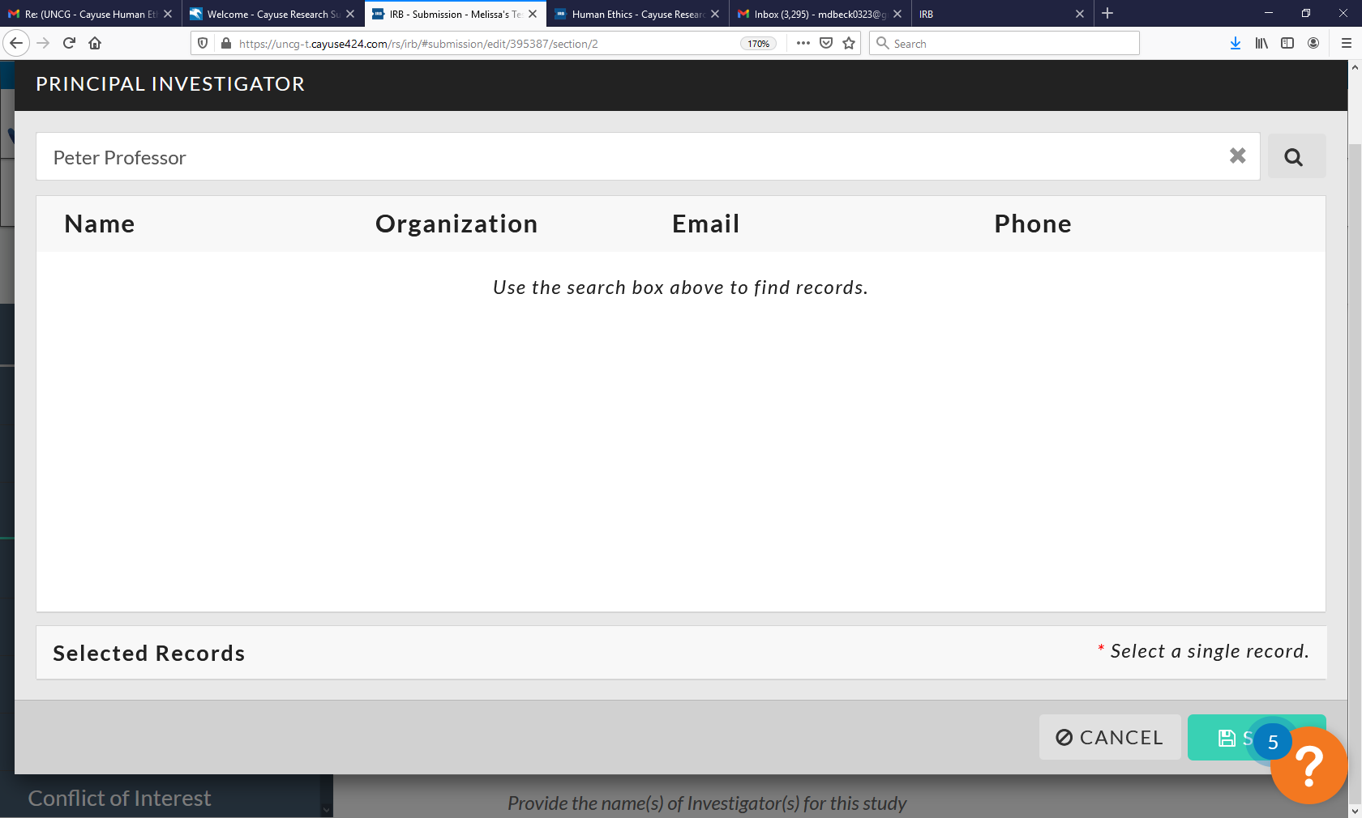

Select staff member(s) and hit save (Note: CITI and Cayuse will interface, so CITI training will reflect when the study team member is added)
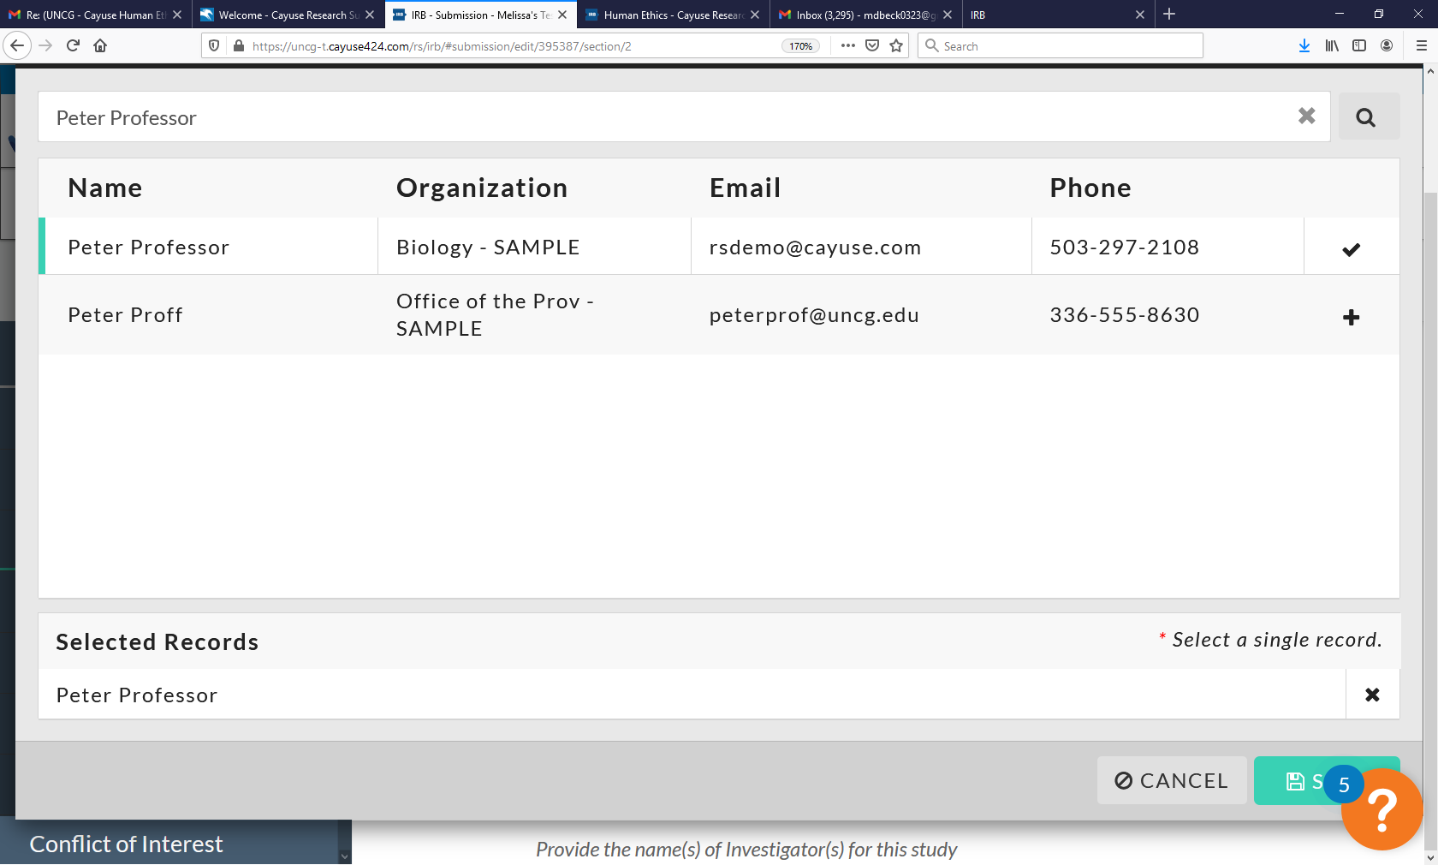
Complete all remaining application sections - when finished, click “Complete Submission” on the left-hand side of the page
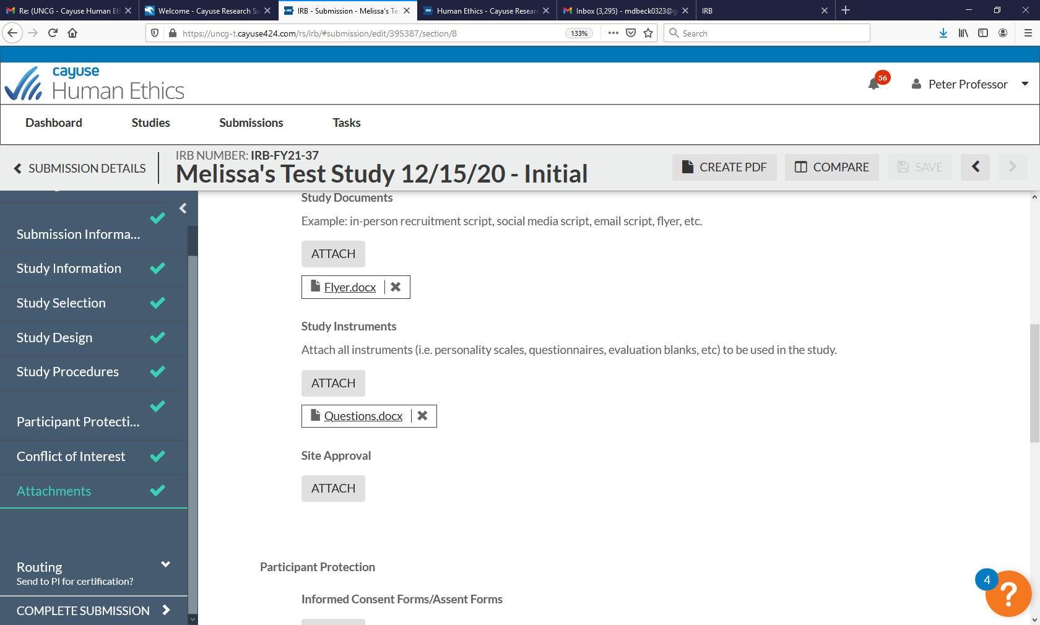

Click “confirm” to continue
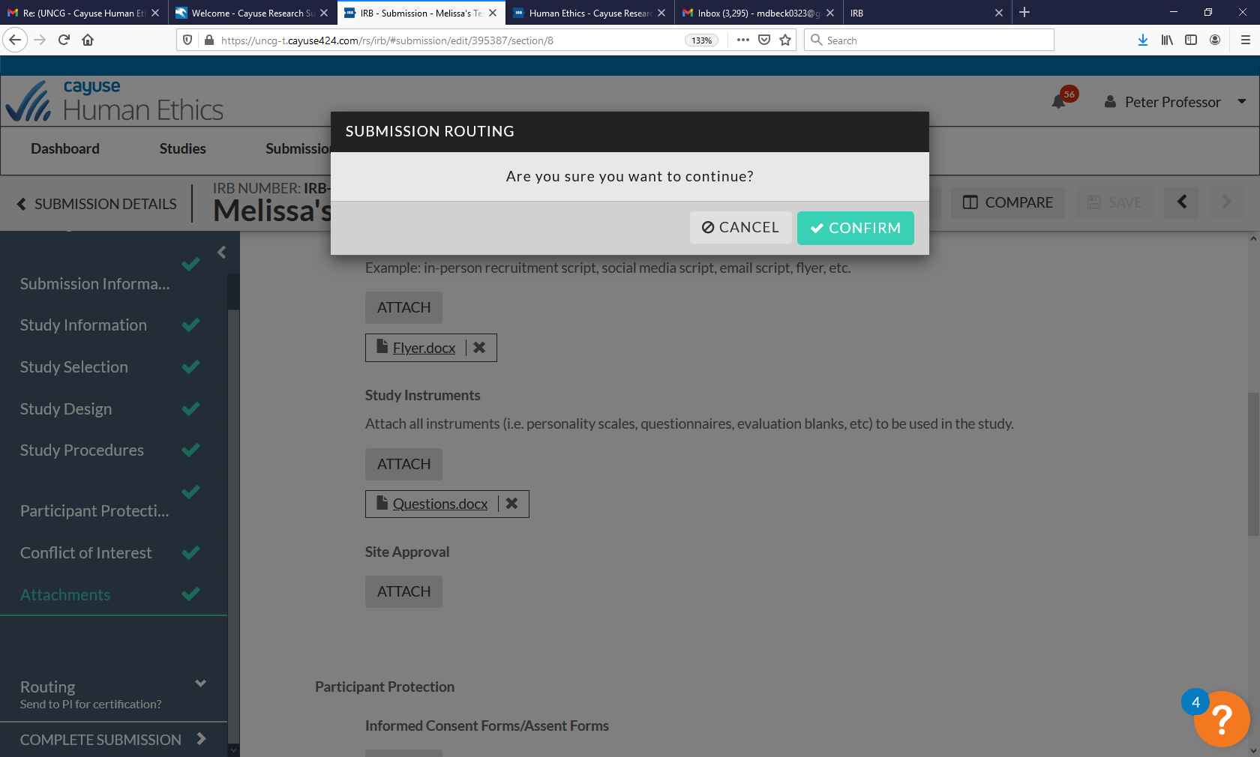
The study will move to the “Awaiting Authorization” status
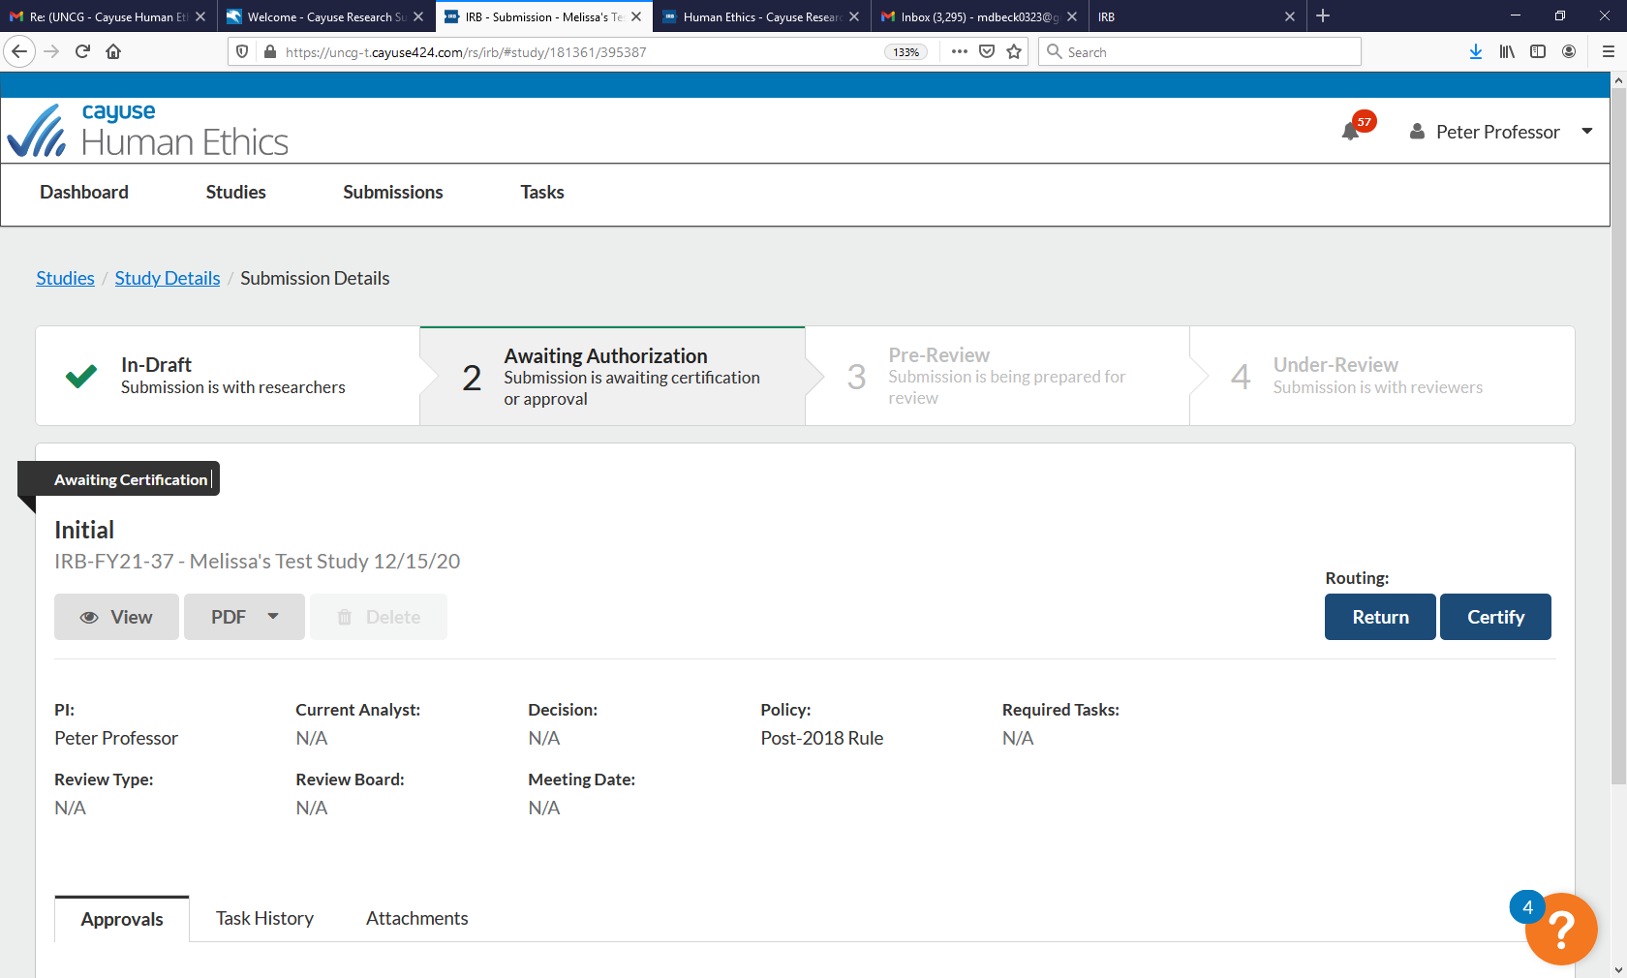

Click “certify” - **Please also see the “Certification Instructions”
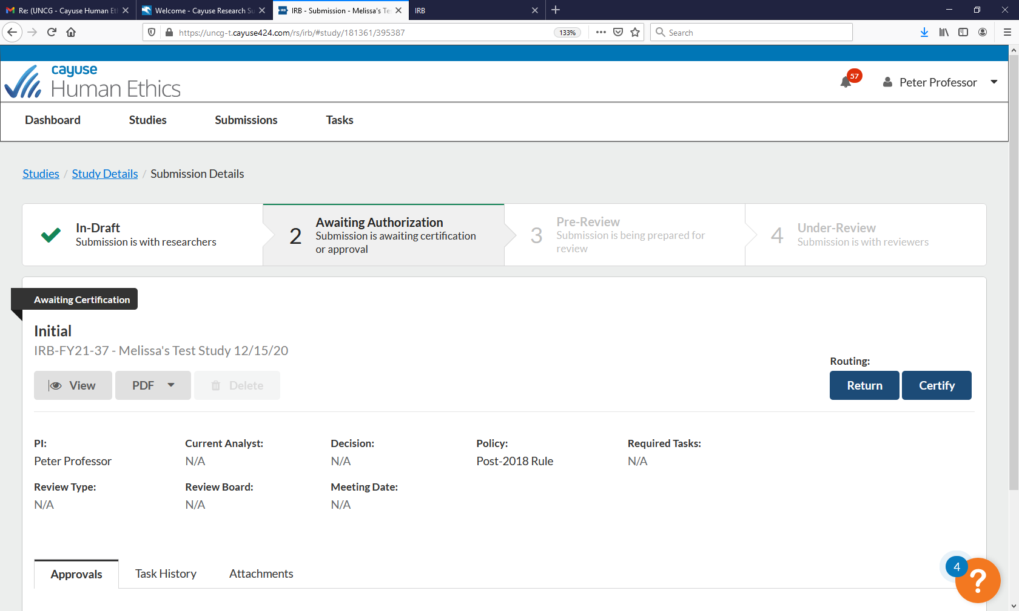
Read the certification attestation and click “confirm” to certify the study, your study will then go to “pre-review”
