Responding to Stipulations
Login to Cayuse Human Ethics - the study will be under “in draft” on your dashboard
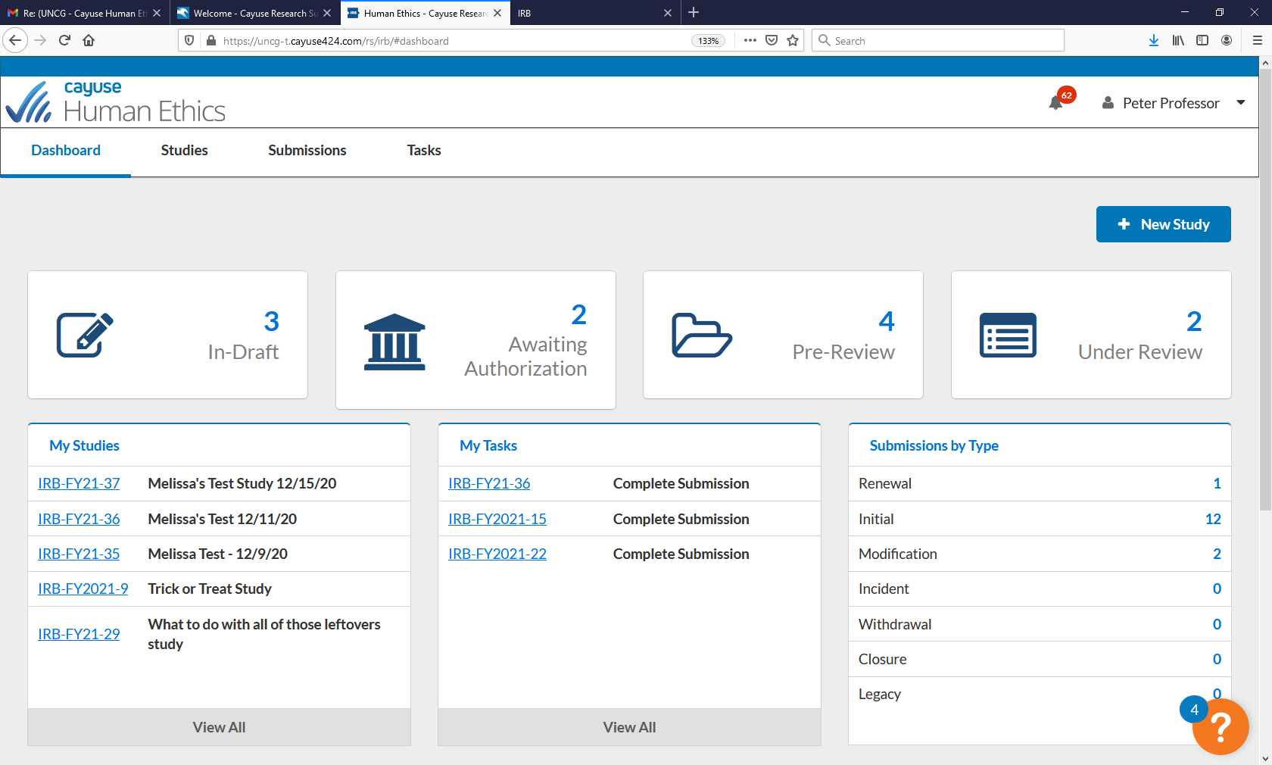
Click the study number
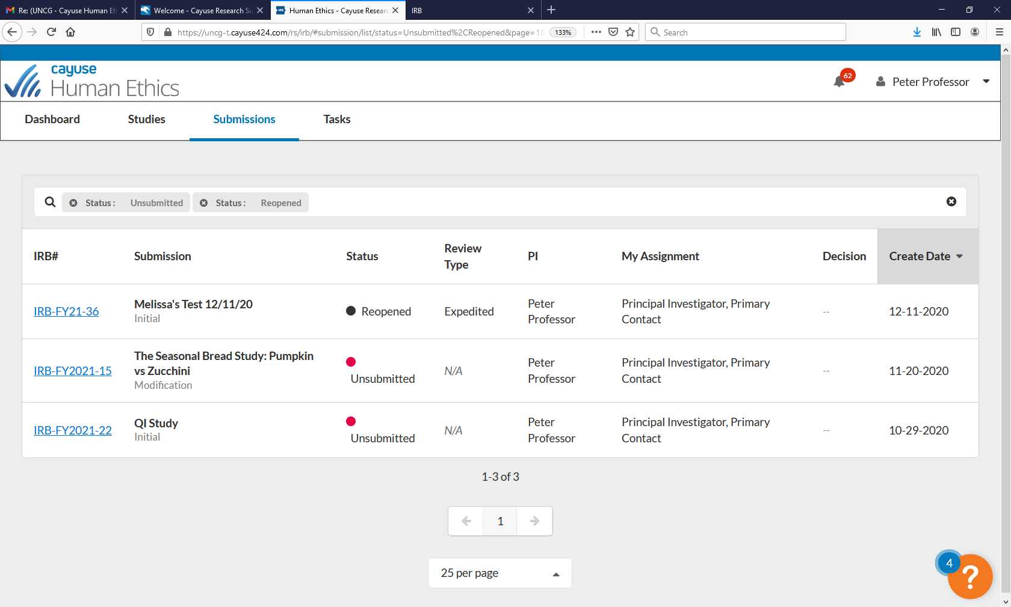
Click the “edit” button
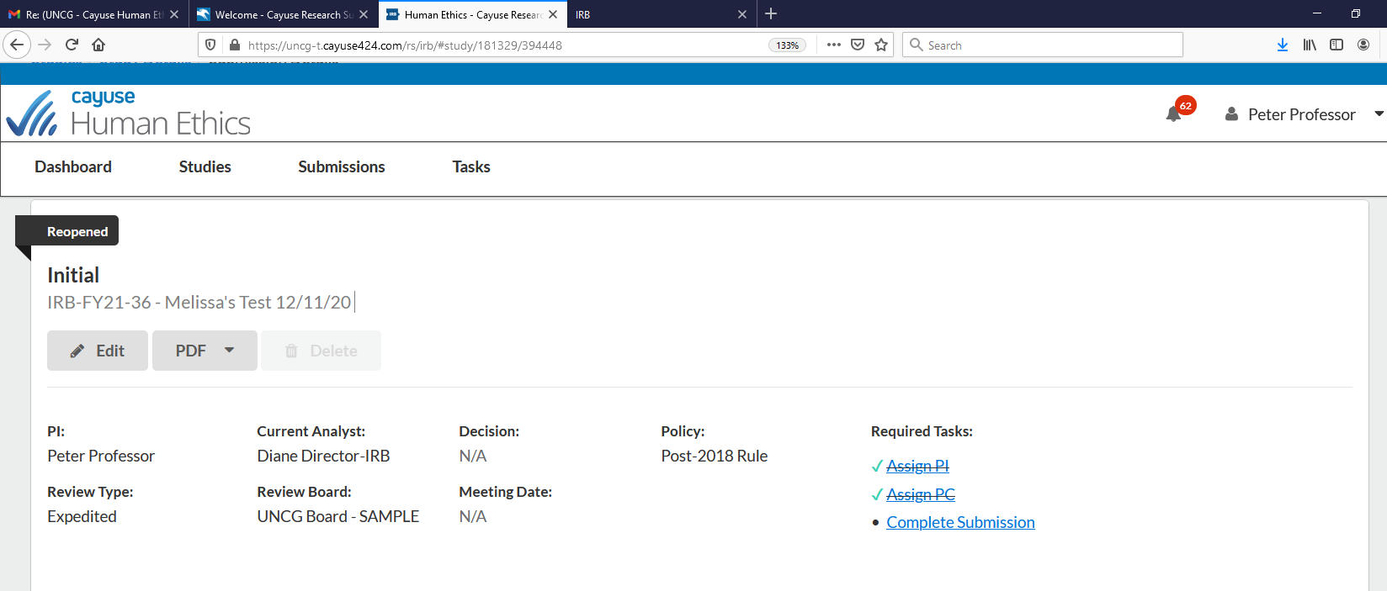
You will see a thought bubble next to the sections that have stipulations click the section with the thought bubble

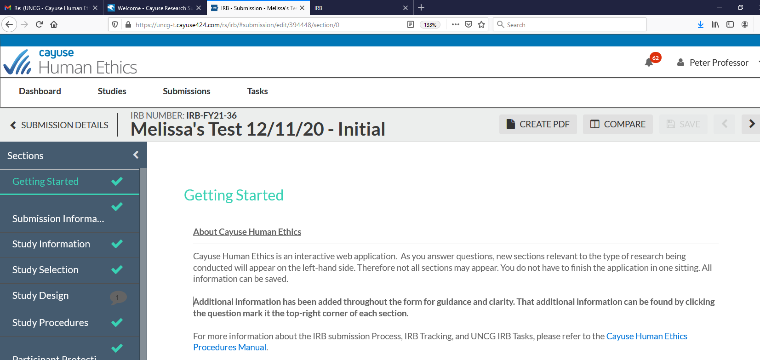

Once at the section with the stipulation, the thought bubble will appear under the section with the stipulation – click “expand comments”
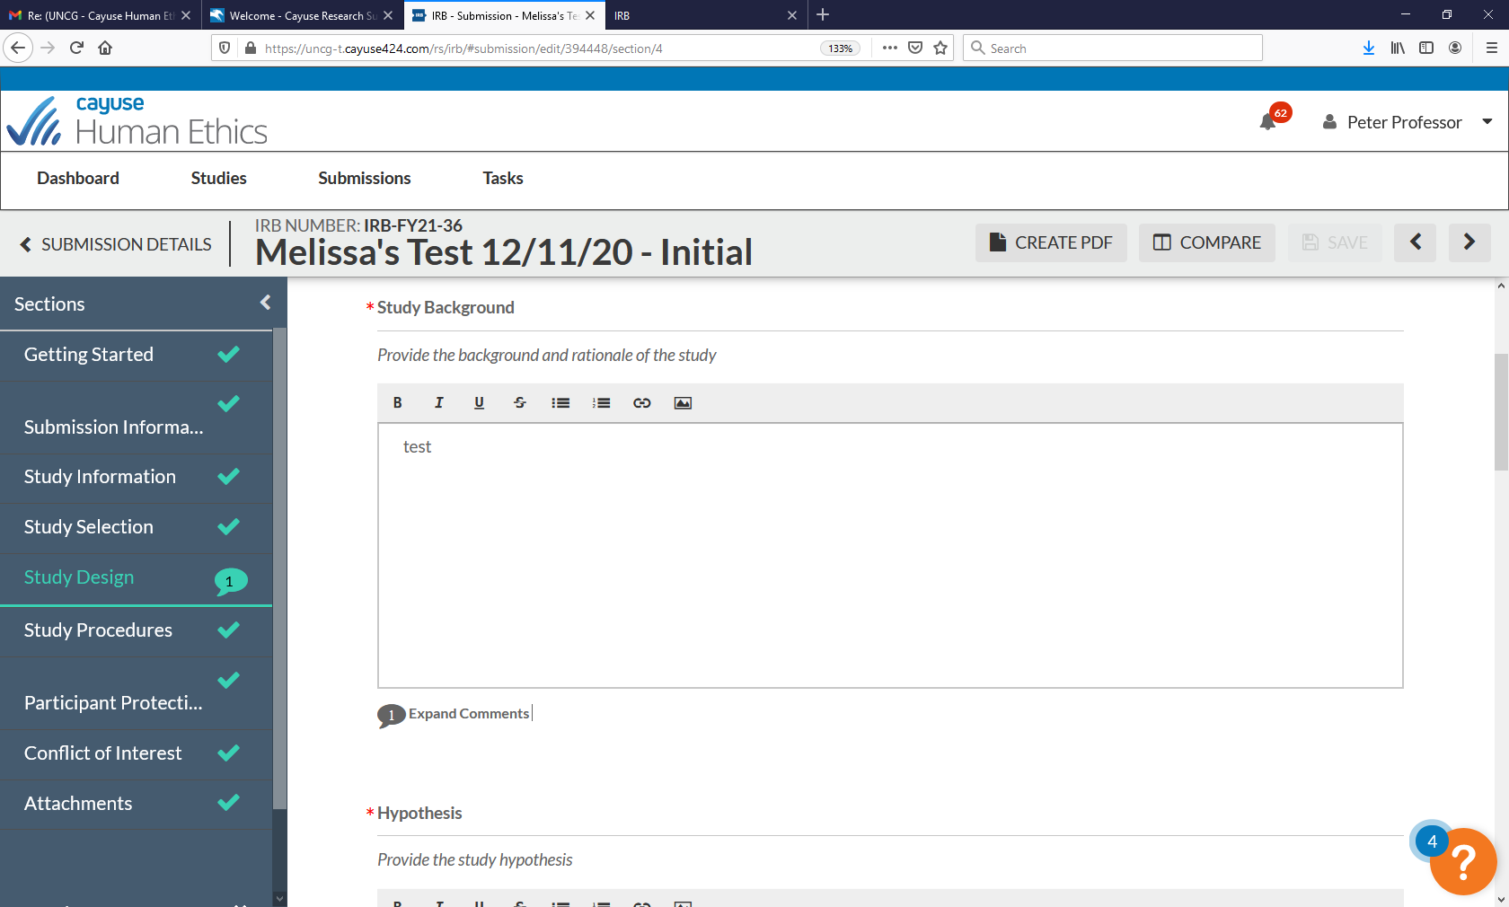
The stipulation will appear. Depending on the nature of the stipulation, you will revise the information in the application section or click reply to be provided with a text box. Please note, if the stipulation specifically requests changes to the section, you must make the revisions to the section.
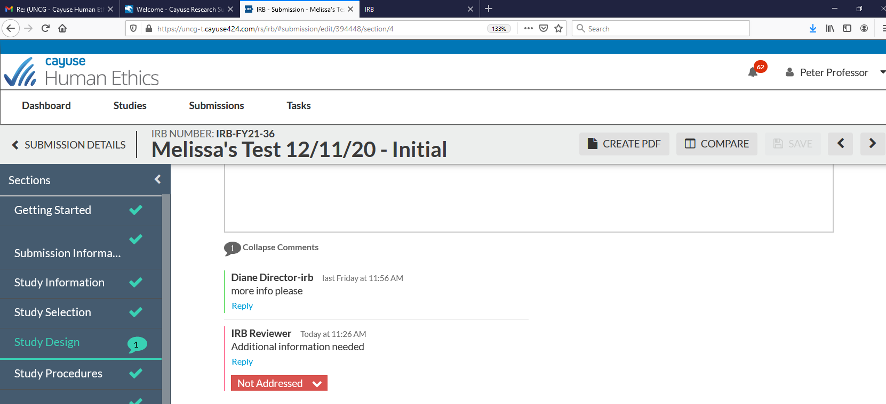

Once the stipulation has been addressed, change the status from “not addressed” to “addressed” by clicking the down arrow under the stipulation
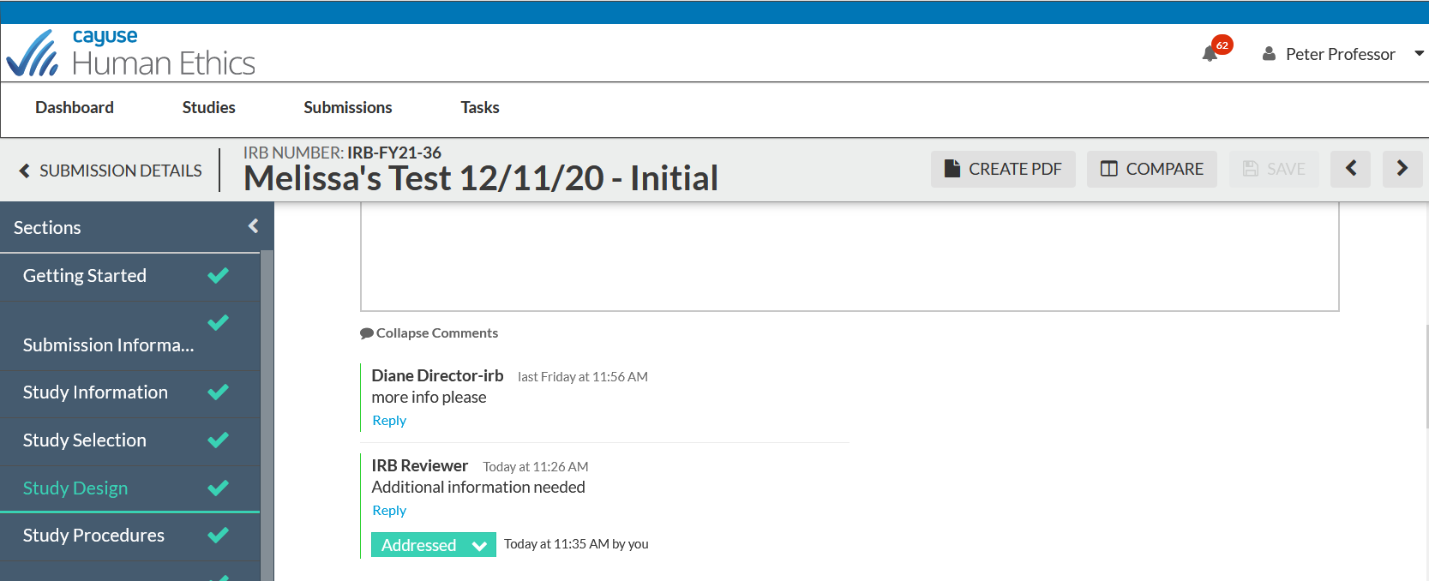
Each stipulation must be responded to before the study application can be returned for review. Once the stipulations have been addressed, click “complete submission” on the left-hand side of the page
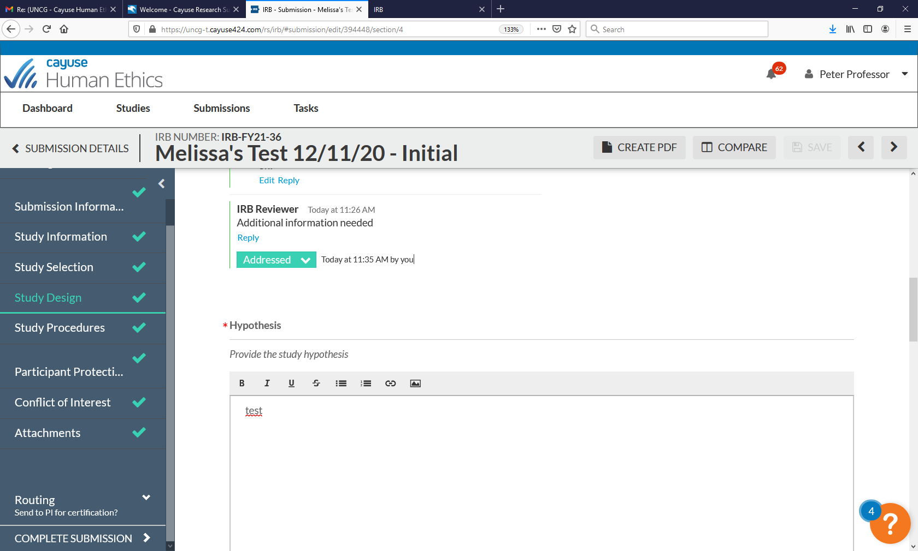

Click “certify”, then “confirm” to finalize the certification - the study application will then be returned for IRB review
