Submission Certification Instructions
Login to Cayuse and navigate to your Cayuse Human Ethics dashboard – you can click on the study under “My Studies” or under “Awaiting Authorization”
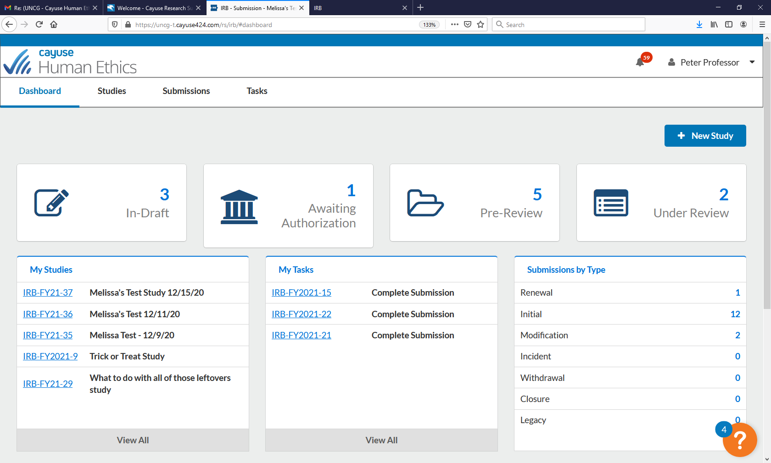
Click on the study number that requires certification
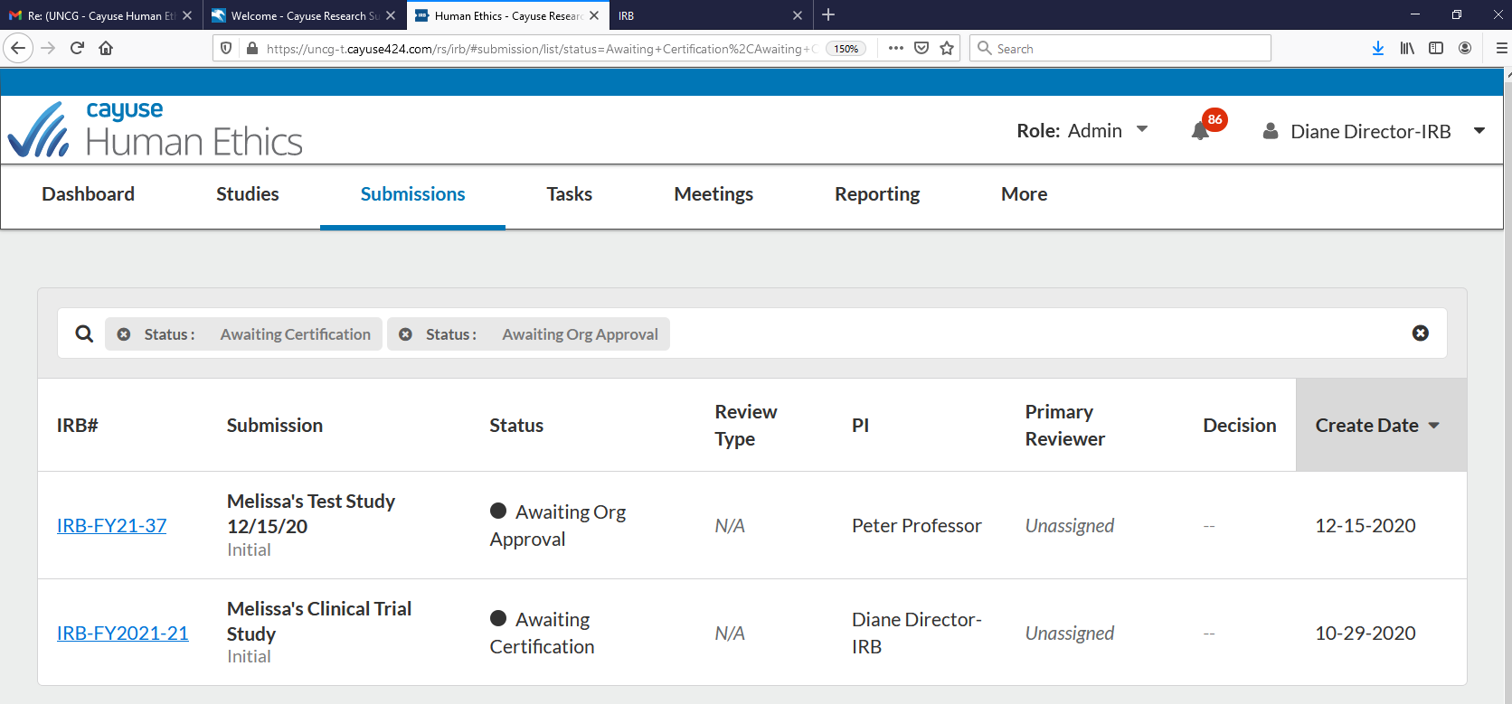

Click “certify”
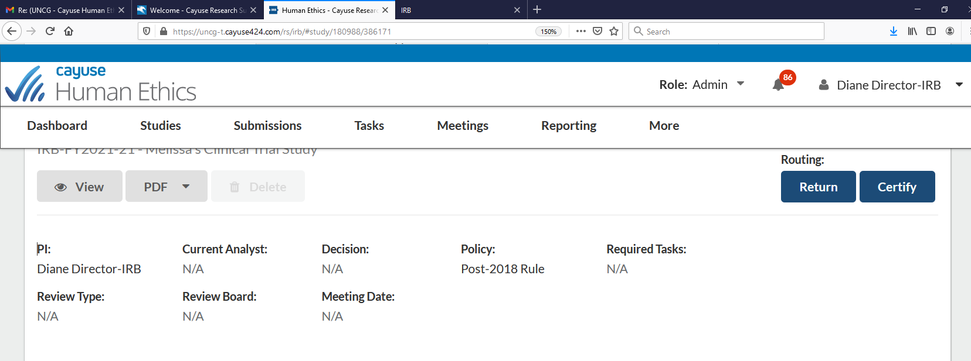

Click “confirm” to finalize certification
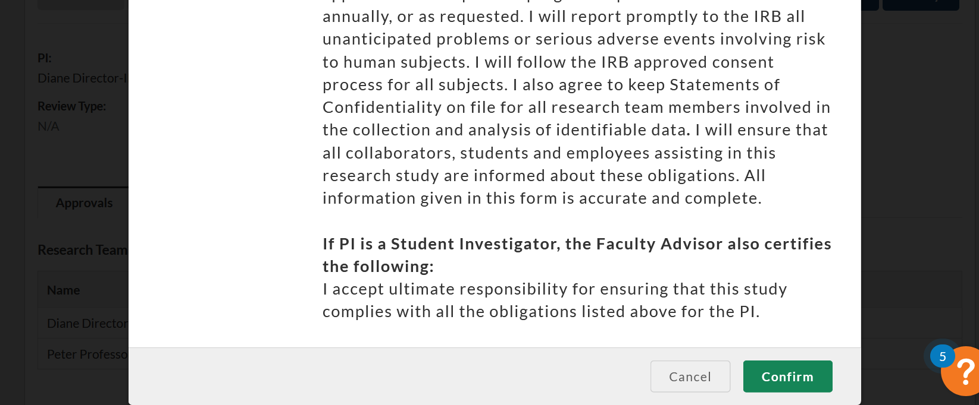
- **The Study must be certified by all required staff - PI and Co-I for faculty/staff led studies and PI and Faculty advisor for all student-led studies/ Once the study application is approved by all staff, the study will move to the pre-review status where it will await assignment to an IRB staff member
- Once assigned to an IRB staff member, it will move to the “Under Review” status – PLEASE NOTE: When a study application is moved to the “under review” status, this means it is in the queue for review – it does not mean the study application is being reviewed that moment – the application can remain in the “under review” status for several days until it is actually reviewed

