To Link and IRB Application to a Cayuse SP Proposal
Click on the study you wish to link under “My Studies”
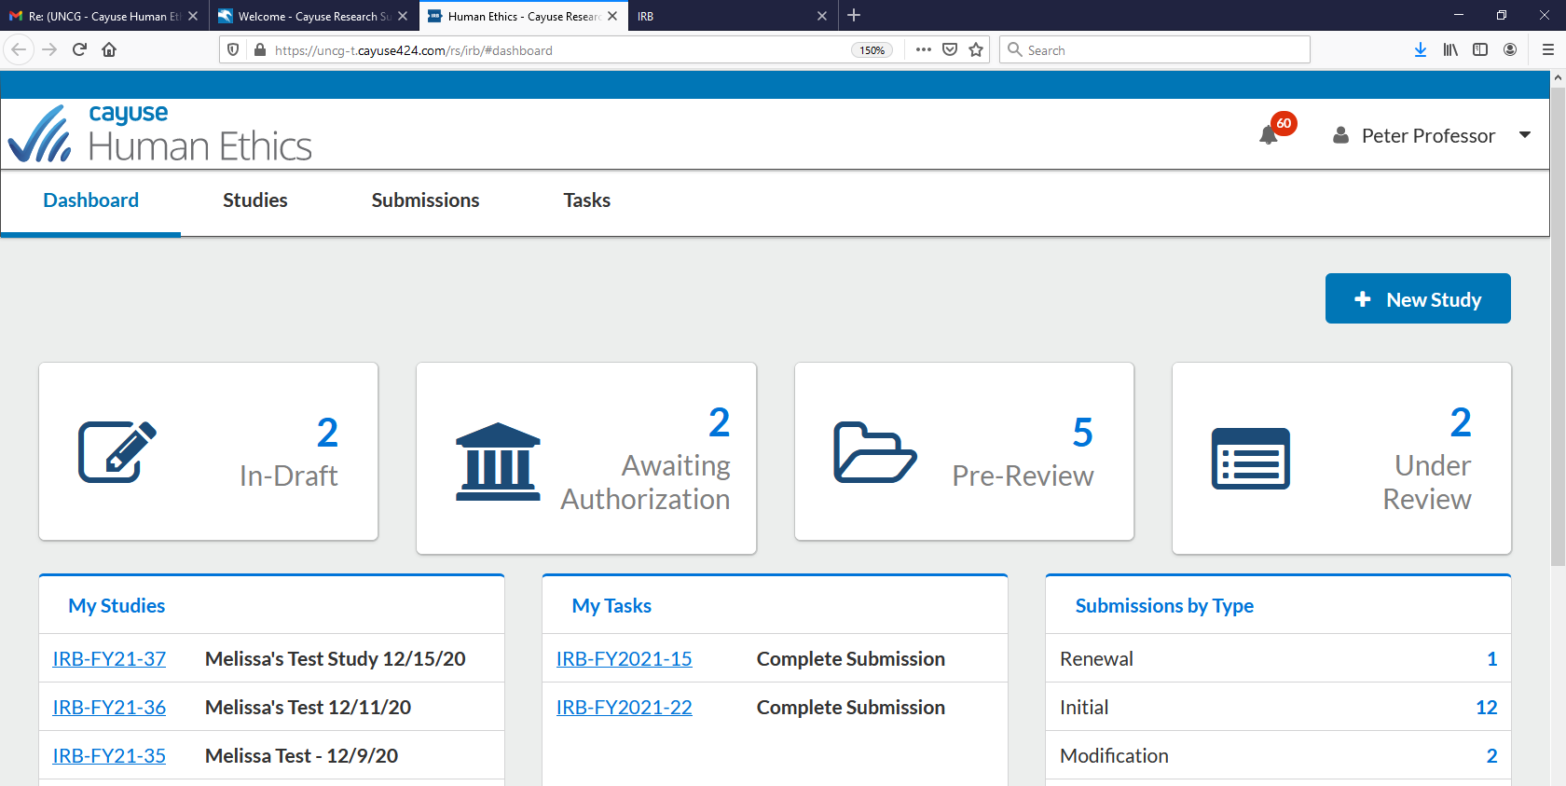
Click “Link Proposal”
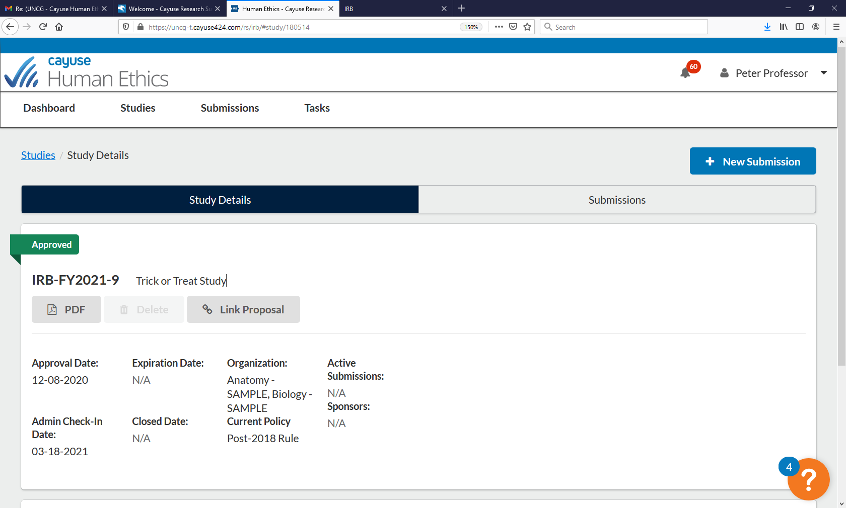

All proposals for which you are affiliated with appear – click button under “linked” next to the appropriate proposal number, when the button turns green, the study is linked to that proposal - Click “Done” on the right-hand side
