CITI Conflicts of Interest Module Instructions

- Go to the CITI website
- If you are not registered with CITI, click the white “Register” button and proceed with the registration process. If you need to create a new account, you will be asked a series of questions. Select University of North Carolina at Greensboro as the participating institution and enter all required name/address information. NOTE: UNCG now uses Single Sign-On, so you do not need a separate CITI username and password. Once you have completed registration, skip to step 4
  - NOTE: If you are not affiliated with UNCG, please input 9 zeros when asked for your UNCG ID during the CITI registration process
- If you have a CITI account but are not affiliated with UNCG, you will need to affiliate. Once logged in to CITI, choose “Click here to affiliate with another Institution”. Under the dropdown “Participating Institutions”, select “University of North Carolina at Greensboro”, then select “Next”.

  - If you would like to receive credit for modules previously taken, there are several requirements that must be met.

- To transfer course credit between institutions, you will need to be affiliated with both institutions (your previous institution and your new institution). Follow the "Click here to affiliate with another institution" link on your Main Menu to add an affiliation.
- When you are affiliated with both institutions, enroll in the courses that need to be transferred under both institutions, via the "Add a Course or Update Learner Groups" link under the appropriate institution if necessary. You will need to enroll in the same stage of the course (Basic / Refresher) for a proper transfer to occur.
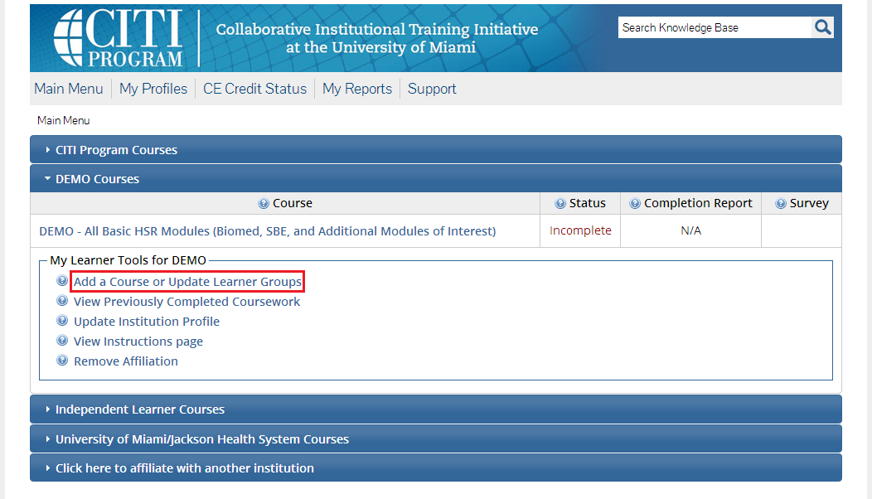

- Once you are enrolled in the courses, any modules that are shared between the courses between institutions will have their credit transferred automatically. The transfer is based on each module's unique ID number. If the courses do not match exactly, not all credit will transfer and you may need complete the difference in modules at your new institution to get full credit for a Completion Report.
- Each institution determines the time frame in which modules are transferable. This time frame can span any time between 1 and 10 years. Some institutions opt out of this option and do not allow modules to transfer.
- If you are registered with CITI, Click "login through my institution", search for University of North Carolina at Greensboro, click on University of North Carolina at Greensboro, and login using your UNCG credentials
- Once logged in, click “add a course” at the bottom of your CITI homepage
- Click “Responsible Conduct of Research”, then the “Next” button
- Click “Conflicts of Interest”, then the “Next” button
- You will see the “Conflicts of Interest” course loaded under “Courses Ready to Begin”

